** COMSATS University Islamabad, Attock Campus Department of computer Science**

**Program: BSE**



**Course: DS**

**Assignment No.: 01**

**Registration No.: SP23-BSE-015**

**Name: Hamza Liaqat**

**Date: 24 Sep, 2024**

**Submitted to: Sir Kamran**

# Introduction:

This report describes the implementation of a task management system using a singly linked list in C++. The system provides functionalities to add, view, and remove tasks based on their priority or task ID.

# Code Explanation:

* Task struct:

Defines the structure of a task, including its ID, description, priority, and a pointer to the next task in the list.

* headpointer:

Points to the first node (head) of the linked list.

* addTaskfunction:

Adds a new task to the list at the correct position based on its priority.

* removeHighestPriorityTaskfunction:

Removes the task with the highest priority from the list.

* removeTaskByIdfunction:

Removes a specific task from the list using its ID.

* viewTasksfunction:

Displays all tasks in the list.

* mainfunction:

The main entry point of the program, handles user input and calls the appropriate functions.

# Screenshots:

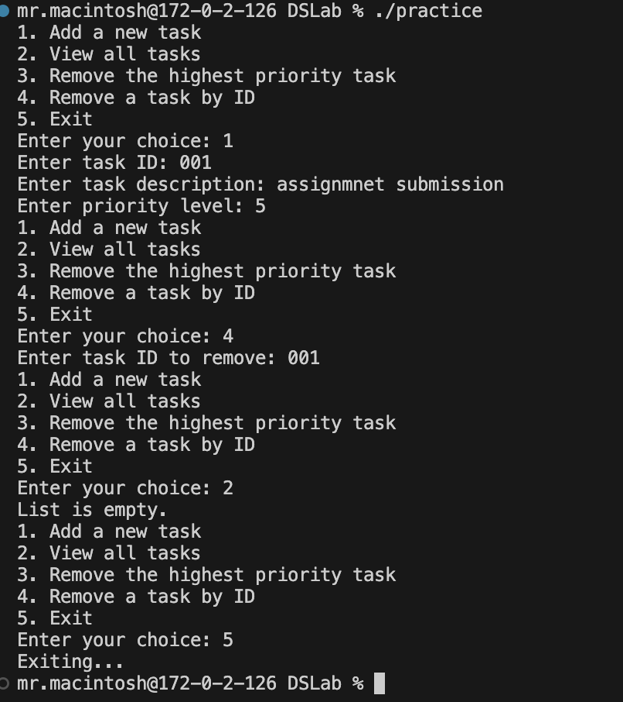

# Conclusion:

Through this assignment, I gained a deeper understanding of singly linked lists and their applications. I learned how to create and manipulate linked lists in C++ to implement various data structures and algorithms. I also encountered challenges in handling edge cases and ensuring efficient memory management. Overall, this assignment was a valuable learning experience.